We recommend watching Baptist Children and Family Ministry ‘Training Video 2: ‘Choosing Material’.
(baptistcfm.org.au/training-videos)
CHOOSING THE BEST Curriculum FOR KIDS MINISTRY

Kids’ Ministry Training Video 2:
Choosing Material

With so many curriculums available, it can be hard to decide which is best for your church. The following is a list of areas that may be helpful to consider when selecting a children’s ministry curriculum for your group.

Vision & Values
❑ Vision: Does the curriculum fit with the vision of your church?
❑ Values: Does the curriculum enable leaders to operate within the values of the church?

Theology
❑ Beliefs: Does it teach content which is in alignment with your church’s theological beliefs?
❑ Childhood: Does it deliver lessons which are in alignment with your church’s theology of childhood?
❑ Accuracy: Has the content been made age-appropriate, while still maintaining theological accuracy?
❑ Grace: Does it point to God’s grace, Jesus’ salvation and the Holy Spirit’s power, or is it suggesting we earn our salvation?

Learning & Engagement
❑ Learning Styles: Does it include a variety of learning styles - listening, discussion, and hands on activities?
❑ Application: Is there an opportunity for kids to open the bible for themselves, and apply it to their lives?
❑ Transformation: Is learning purely intellectual, or does the material aim for heart transformation?

Scope & Sequence
❑ Approach: Does the material progress chronologically through the Bible? Or are they topic-based?
❑ Length: How long will the curriculum last? Is material for a term only, or for birth through high school?
❑ Repetition: Is the material repetitive, or are kids engaging with new stories and content?

Age-appropriate
❑ Child Development: Is it appropriate for the developmental stages of your group?
❑ Faith Development: Is it appropriate for the various faith development stages of your group?
❑ Transition: Does it provide good transition between age groups?

Family Engagement
❑ Engagement: Does it help parents engage with and take interest in their children’s learning?
❑ Responsibility: Does it support parents in taking responsibility for their child’s spiritual nuture?

Practicalities
❑ Size: Does it work with the number of children you have?
❑ Format: Is it designed for big groups, small groups or a combination?
❑ Budget: Does it fit within your allocated budget?
❑ Resources: Do you have the supplies and equipment available to make it work?
❑ Volunteers: Does the program require additional leaders, and do you have sufficient volunteers?
❑ Preparation: Is the amount of preparation required practical for your volunteers?
❑ Adaptation: Can it be adapted to meet the opportunities or limitations of your context?

MODULE ONE: GETTING STARTED
It’s rare that you will find the perfect curriculum, so perhaps the most important question to ask is: “Can it be adapted to meet the opportunities or limitations of our context?”
When you source a new curriculum, it can be helpful to go through each of the above checkpoints to determine what makes it a great fit, and which areas might need to be adapted. Having worked through this list, you might determine that you need to add in some more hands on activities, reflection spaces or find a way to help parents engage in the material or find two extra leaders to facilitate effective small groups. Decide which of these areas are most important to you (and you are not willing to compromise) and what changes you are prepared to make.
Further Reading:
Books:
‘Wholly Kids: Guiding Kids to Life in Christ’ by LifeWay Kids
‘Think Orange: Imagine the impact when church and family collide’ by Reggie Joiner

Websites:
http://www.discipleblog.com/2012/12/childrens-curriculum/
https://childrensministry.com/pick-winning-curriculum/

Questions for Your Team
- Go through the list and use the checkpoints to assess your current curriculum.
- Are there any areas that we need to adapt in our current curriculum? How will we do this?
- What should we remember to specifically look for when choosing our next curriculum?
- How can we better engage and equip parents to take the lead in the nurturing of their child’s faith?

Children’s Ministry Curriculums

Below are a number of children’s ministry curriculums that are currently being used in various churches Kids’ programs. Please note that they are included below for comparative purposes only, and the Baptist Association NSW & ACT does not necessarily endorse their content or activities. We encourage you to take a look at our training video on choosing curriculums as well as our written resource available on our website.
Contents
At Home Pack
- BiG Curriculum Hillsong Kids 6
- Children’s Ministry Deals Children’s Ministry Deals 7
- Dig-In Discipleship: CEP Penny Reeve 8
- Discovery Learning Series Tammy Tolman 9
- D6 Curriculum D6 Family 10
- GO! Curriculum David Rausch, Mooblio 11
- GodSpace Baptist Churches NSW & ACT 12
- Gospel Light David C Cook 13
- Grow Kenny & Elle Campbell 14
- Jesus Storybook Bible Curriculum Zondervan 15
- Kids@Church CEP 16
- Kids Sunday School Place Kids Sunday School Place 17
- Kidswise Sandy Galea 18
- Let Your Light Shine Baptist Churches NSW & ACT 19
- Life Kids Life.Church 20
- Light Scripture Union 21
- Lost Sheep Andrew McDonough 22
- Max7 Logosdor 23
- 7Ways BibleMAX Series Logosdor 24
- Oasis Logosdor 25
- Saddleback Kids Saddleback Church 26
- Tell Me About God Baptist Churches NSW & ACT 27
- The Meeting House Kids and Youth Curriculum The Meeting House 28
- Think Orange rethink Group 29
- Tru David C Cook 30
- Bible Studies for Life LifeWay Kids 31
- The Gospel Project LifeWay Kids 32
- Explore the Bible LifeWay Kids…………………………………………………………………………………………………. 33
- Lectionary based resources
- Seasons FUSION Seasons of the Spirit 35
- Spill the Beans Spill the Beans 36
- ROOTS ROOTS for Churches 37

BiG Curriculum
Hillsong Kids
www.hillsong.com/kids/big

All inclusive resource, including multimedia teaching, quiz review segments, praise & worship tracks & videos, Bible verse videos, and all print material.

Country | Target Age Group | Length | Price
Australia | Series One includes material for children  (5-6 yrs, 7-9 yrs,  10-12 yrs).  Series Two additionally includes material for preschool (1-6 yrs).  BIG + subscription includes streaming of all BIG curriculum material for all ages (1-12 yrs). | Series One: 4 x 13 week series  Series Two: 9 lessons per title  Series Three: 9 lessons per title  Entire series (past, present and future) | Series One:  Can be purchased as  4 or 5 lesson packs,  3 month packs or  12 month packs.  Series Two:  $180 per 9-lesson title for children OR preschool. Or buy all four titles for $800  $180 per 9-lesson title for BOTH children and preschool.  $50 (minimum 12 month subscription)

Strengths:
- Can be used with any number of children, in large groups, small groups or a combination
- High quality, well produced video material
- Simple to prepare – you simply need a TV and DVD player (or projector, screen and DVD player)
- A take-home activity sheet is included.
- BIG + subscription is available with Safari, Firefox, Explorer, Chrome

Considerations:
- Reliant on multi-media presentation of material
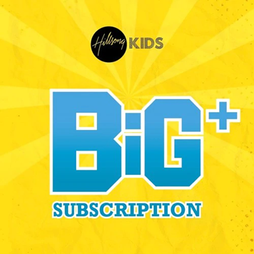
- BIG + subscription requires wi-fi (no downloads available)

Children’s Ministry Deals

https://www.childrens-ministry-deals.com/

Children’s Ministry Deals produces curriculum that teaches kids Bible lessons in a way that is intentionally fun and engaging.

Country | Target Age Group | Length | Price
USA | Pre-school (1-5yrs)  Elementary 6-12 yrs  Preteen (10-13 yrs) | 4 weeks  Vary in length (4, 8, 9, 12 weeks)  4 weeks | Prices vary ($0-$100)  Average price $75  Average price $75  Average price $25

Strengths:
- Each lesson includes a memory verse, craft, skit/puppet show, object lesson, large group game, small group discussion, lesson outline, parents’ sheet and instant lesson download.
- Direct access to Pinterest Board for the craft

Considerations:
- The content of each series is not always clearly reflected in the series’ title.
- Some of the titles, games and themes are strongly associated with USA cultural references

This company also offers ‘Family Bible Lessons’; resources to equip parents at home. Each theme includes approximately 8 topics. Price range: $30, $45 or $55.

Dig-In Discipleship: CEP
Penny Reeve
http://www.discipleship.net.au/

Bible study discipleship series for children aged 10-12 to explore God’s word as a transitional step between Sunday school and Youth group.

Country | Target Age Group | Length | Price
Australia | Designed for children aged 10-12 yrs. Could be considered for 8+ | 7 books published with 6 programs each | $6.95 per 6-lesson book (one needed for each child)

Strengths:
- Australian resource specifically targeted for pre-teens in a way that is fun, thought provoking and applicable.
- Continually interacts with the Scriptures throughout the whole study.
- Interactive. Variety of activities, simple to prepare and easy to adapt.
- Perfect for small group settings.
- Affordable

Considerations:
- This material is designed and produced specifically for 10-12 year olds.

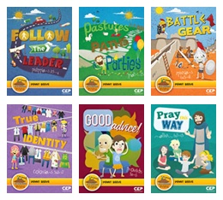

Discovery Learning Series
Tammy Tolman
www.discoverylearningseries.com

A four year curriculum through which children will experience the breadth and depth of the entire Bible, anchored by the story of Jesus’ life, death and resurrection and what it means today.

Country | Target Age Group | Length | Price
Australia | 8-12 yrs | 4 year curriculum  (16 modules,  approx 10 weeks each). | $15 per 1-week bundle  $50 per 1-term module  $150 per 1-year package

Strengths:
- Can create your own custom lessons based on Bible reference, character or theme.
- Children learn by participating; by active engagement in a stimulating and enjoyable experience. Offers variety of learning methods – analytical, emotional, physical, experiential.
- Completing all 16 modules will give children both a strong understanding of the entire Bible, and the overarching story of salvation through Jesus.
- All files can be directly downloaded to your computer including lesson plans, drama scripts, songs (lyric sheets, overhead slides) and extras (nametags, badges, posters, T-shirt designs, PowerPoint slides, reward cards, etc).
- Offers flexibility: either a stand-alone teaching experience or teaching as part of a whole module.

Considerations:
- This curriculum uses drama scripts to support teaching. Consider who amongst your team are interested in acting and might enjoy this.

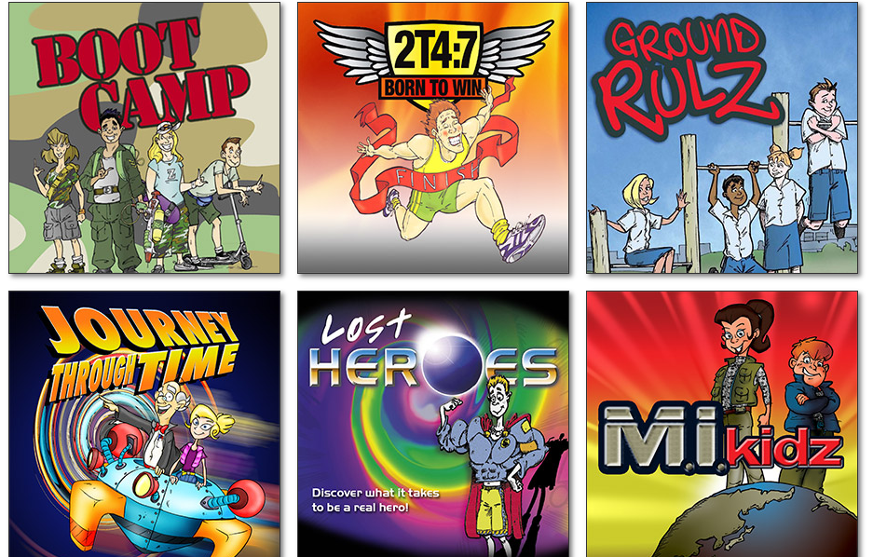

D6 Curriculum
D6 Family
https://d6family.com/a-d6-church/

D6 connects the church to home and families to one another. This curriculum is designed for small group and Sunday Kid’s Program settings. D6 is based on the principles of Deuteronomy 6:5-9—love God, love His Word, and teach your children to do the same.

Country | Target Age Group | Length | Price
USA | Separate material for:  Infant/toddler, 2-3years, 4-5years, Year K-1, Year 2-3, Year 4-5, Young teens | Quarterly curriculums available for purchase | * Teaching resource (Bundle) $149  * Teaching resource (only) $66  * Teaching resource (Digital) $55

Strengths:
- Designed to create a partnership between church and families. Offers activities for families to do together to reinforce what was learned
- Bundle packs include: 1 teaching essentials, 1 teaching guide and 10 children’s guides
- Available in 4 different Bible translations
- Offers option of digital format (equivalent to content in the Bundle)

Considerations:
- These curriculums would have to be purchased quarterly, so consider the time frame you have in mind when buying D6.

GO! Curriculum
David Rausch, Mooblio
https://www.gocurriculum.com/

GO! is a downloadable children’s ministry curriculum designed for preschool and primary school kids. GO! takes kids through the entire Bible once a year, but it uses different stories each time around. “The GO! curriculum is chronological, gospel-centred, God focused, faith forming and filled with fun.”

Country | Target Age Group | Length | Price
USA | Aligned material for both preschool (2-5 years) and elementary (Year K-5) age kids. | Individual units: 4-5 weeks.  12-month subscriptions. | Preschool:  - US$75 per unit  - US$450 for 12-month subscription (1-25 kids)  - US$599 for 12-month subscription (26-75 kids)  - US$750 for 12-month subscription (76-250 kids)  Elementary:  - US$99 per unit  - US$599 for 12-month subscription (1-25 kids)  - US$799 for 12-month subscription (26-75 kids)  - US$999 for 12-month subscription (76-250 kids)

Strengths:
- GO! can be changed and adapted to fit your ministry context and the children you have.
- Keeps the Big Story of the Bible in focus
- Includes leader reflections and training ideas.
- Parent resources encourage discussion
- Social media links: GO! Facebook page posts a preview of the coming lesson (would need to search for the one relating to material you are using) that you can share with the parents of your church on your own Facebook page.

Considerations:
- The scope and sequence for the 12-month curriculum follows the American school year (from August-July), so you would need to consider how to adapt this.
- Cost may be out of reach for some churches

GodSpace
Baptist Churches NSW & ACT
www.gosdspace.org.au

Aussie Bible lessons, which take the truths of Scripture that are relevant to contemporary children and use engaging activities and the children’s life experiences to help them grasp the truths for themselves.

Country | Target Age Group | Length | Price
Australia | Separate material for  4-6 yrs, 6-8 yrs,  8-10 yrs, 10-12 yrs.  4-6 yrs (‘Discoverers’: children in first year of school)  All ages | 3 year curriculum  (30+ lessons each).  30+ lessons  Semester | $65 per year for teacher’s resource pack (all ages).  $45: stand alone set of lessons  $4 per semester  for student book  (one needed for  each student)

Strengths:
- 1 manual provides teaching ideas and adapted material for kids aged 4 - 12years
- 3 year curriculum low cost
- Written by experts from a diverse range of backgrounds experienced in Theology and Teaching to ensure the Bible is presented in a contemporary way that children see as relevant
- Suited for those with little preparation time: Teachers resource pack includes usb – Bible passage printouts, memory verse posters, scripts and songs

Considerations:
- GodSpace material designed for children who are new to the Bible – therefore can be used for Kids Club and Scripture (or Sunday School with a large proportion of children from the community).

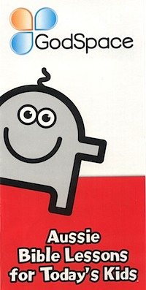

Gospel Light
David C Cook
www.gospellight.com
Available from Koorong

Age-group targeted curriculum based around five pillars – the Bible, relationships, a comprehensive plan, changed lives and Jesus.

Country | Target Age Group | Length | Price
USA | Gospel Light provides materials from birth through to adulthood, across a range of programs.  Their “Sunday School” program offers separate material for: Nursery  (0-18 months, 18-36 months), Preschool  (2-3 yrs, 4-5yrs), Elementary (Years 1-2, Years 3-4), Pre-teen (Years 5-6)  Years 1-4 | Nursery: 2 year program  Preschool: 2 year program (purchased by the term in 13-lesson curriculums).  Elementary: 4 year program (purchased by the term in 13-lesson curriculums)  Pre-teen: 2 year program (purchased by the term in 13-lesson curriculums).  Purchased by the term | $139.99 USD  Teacher’s Classroom Kit for Preschool, Elementary or Pre-teen: $149.99 USD per term for materials for one leader and 10 children. Materials for additional children can also be purchased.  Also sold through Koorong  Teacher’s Classroom Kit: Multi-age curriculum $209.99 USD

Strengths:
- Every lesson points directly to Jesus, with a clear connection.
- There is a strong value on relationships: discipleship and evangelism
- The curriculum considers child development, offering a complete plan from birth through to adulthood.
- There is a focus on life application in each lesson.
- Hybrid options: digitally or in person
- Support available from ministry services team
- Digital download version suits churches with small team, limited budget
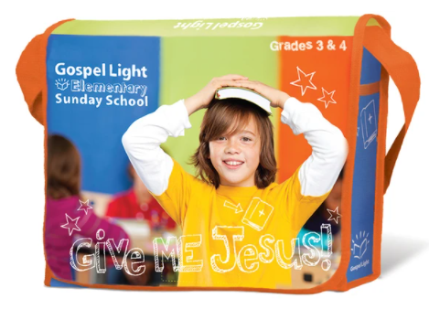
Considerations:
- Produced in the USA, so needs adapting to the Australian context.

Grow
Kenny & Elle Campbell
https://growcurriculum.org/childrens-ministry-curriculum/

Grow Children’s Ministry Curriculum and Annual Strategy is an all-inclusive program: volunteers, parents, teaching, discipleship, weekly programming and events.

Country | Target Age Group | Length | Price
USA | Preschool age and elementary age (5-11) curriculum. | 12 months’ worth of curriculum. | US$597 – 1 payment for an annual subscription. Includes curriculum, discipleship & programming areas.  US$997 – 1 payment for an annual subscription for the above. Also includes material for volunteers, parents and events.

Strengths:
- Curriculum is customisable no matter a church’s size, format or calendar.
- Particularly designed for preschool and primary aged kids but can also be adapted for preteens. Material is designed for both separate/combined age groups.
- Grow has considered inclusion of kids with additional needs.

Considerations:
- Grow isn’t just a children’s ministry curriculum. The weekly curriculum is just one part of an overall strategy, so you would need to consider which parts of this curriculum will work within your context.

Jesus Storybook Bible Curriculum
Zondervan
https://www.sallylloyd-jones.com/books/jesus-storybook-bible/curriculum-kit/

Based on the award-winning Jesus Storybook Bible, this curriculum reveals how Jesus is the centre of each Bible story, and how every story whispers his name. Contains activities, animated videos, notes for teachers, memory verses, handouts for children and more.

Country | Target Age Group | Length | Price
USA | 4-7 year olds. | 44 lessons | $149.99 (from Koorong)

Strengths:
- Whole Bible curriculum that highlights the Big Story of Jesus throughout.
- Curriculum kit includes all materials on DVD-ROM, so both teacher material and student handouts can be printed and distributed.

Considerations:
- Activities suggested in the curriculum are limited, particularly lacking in craft or hands on activities. While the curriculum is a good base with excellent teaching concepts, some churches have found it necessary to prepare additional interactive activities.

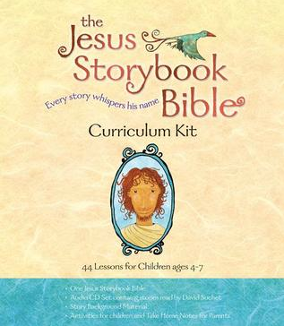

Kids@Church
CEP

https://www.cepstore.com.au/IdaSearchAYW?menu=Children&submenu=kids%40church

The Kids@Church series from CEP is designed specifically for weekend children’s programs, covering the whole Bible over 3 years.

Country | Target Age Group | Length | Price
Australia | Separate material for:  3-5 yrs (Serious Play); 5-7 yrs (Adventure);  8-11 yrs (Over The Top) | 3 year program  (12 units of 10-week modules) | $19.95 per unit for digital or hardcopy leaders’ manual.  $29.95 per unit for digital leaders’ pack.  $2.75 per unit for child’s book (one needed per child).

Strengths:
- Each unit can be purchased at any time, giving leaders the flexibility to plan ahead and tailor children’s programs to fit with specific sermons series and Christmas/Easter.
- Some units look at one section of the Bible, while others look at a theme drawing upon several parts of the Bible.
- Having resources for multiple age groups following the same topics makes it easy for mid-size churches. Children can all be in the same room for part of the session, then split off into small groups for age appropriate activities, prayer and fellowship time.

Considerations:
- Some churches have found the posters quite small and preferred to prepare their own visual aids.
- There are very few craft ideas, so if you like to consolidate your lessons with craft, you’ll generally need to organise your own.

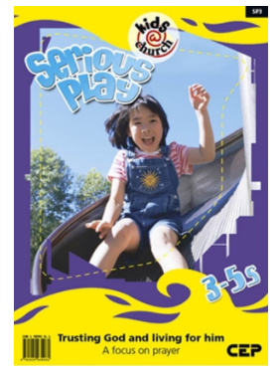

Kids Sunday School Place
www.kidssundayschool.com

Online resources for preschool and primary school, including complete lessons, as well as crafts, activities, talks, skits, games and songs.

Country | Target Age Group | Length | Price
USA | Separate material for Preschool & K-6. | 144 lesson plans currently available for preschool.  218 lesson plans currently available for  K-6. | US$39 per year for individual membership (full website access for  1 user).  US$98 per year for group membership  (full website access for 25 users).

Strengths:
- Very cost effective
- Thousands of ideas to customise lessons to suit your group.
- All resources are available to download or print directly from the website.
- Curriculum covers the major stories of the Bible. There is also a topical index which allows you to find ideas for specific subjects and themes.
- Lessons are submitted by a variety of contributors, then adjusted into standardized formats.
- There are a substantial number of free resources (enough to teach for about a year without becoming a member).

Considerations:
- Produced in the USA, so at times needs adapting to the Australian context.
- Variety of contributors means different approaches to different topics. Every lesson plan needs to be reviewed to check alignment with church theology and vision.

Kidswise
Sandy Galea
https://www.kidswise.com.au/

Kidswise’s passion is to see kids lives transformed through Jesus Christ to the glory of God. They aim to resource and equip people for the task of speaking God’s truth into the lives of children everywhere.

Country | Target Age Group | Length | Price
Australia | Under 5’s includes toddlers (1-2 years) and preschool (3-4 years)  School age (5-11 years) | Toddlers: one-year program  Preschool: two-year program, divided by school terms  School age: Units vary in length | Toddlers: coming soon  Preschool: $30 per term program, $20 for resources.  School age: subscribe for yearly membership for access to materials. Varying plans and prices available.

Strengths:
- Majority of the units work their way chapter-by-chapter through books of the Bible, some units are topical.
- Each school-age unit comes includes activity sheets and PowerPoints.
- Resources include children’s talks, programs, audio files, gospel tracks, training ideas and more.
- Australian resource

Considerations:
- Mini movies referred to in the units are not included but can be purchased in the mini movie section of the Kidswise Shop.
- A church can take out a Kidswise Membership by paying a yearly subscription, giving everyone in that church involved in children’s ministry full access for one year. The cost is dependent on the number of children attending on a weekly basis and the package selected.

Let Your Light Shine
Baptist Churches NSW & ACT

A six-week series helping kids to explore what it means in practice to shine the light of Jesus to those around us. Children are encouraged to be love, be involved, be generous, be kind-hearted, and be together.

Country | Target Age Group | Length | Price
Australia | Kindergarten –  Year 6 at school | 6 lesson series | $25

Strengths:
- Produced by the Baptist Association of NSW & ACT so speaks directly into our context.
- The curriculum is based around one of our Association’s values, to be a movement that is mission shaped. As core values are largely set by the time a person reaches adolescence, it is designed to help children explore mission with their peers and leaders, in the hope that they will join in the mission of Jesus, which is also the mission of the church.
- A take home challenge sheet is provided each week to encourage whole families to get on board with the series and strengthen links between church and home.

Considerations:
- As a six-week curriculum, this is great for a short series, but is not a long-term option.

Life Kids
Life.Church
https://open.life.church/categories/314-kids

The LifeKids team creates colourful custom content for kids ages two through 4th grade. They bring Bible stories and messages to life for kids through stories, videos, songs and games.

Country | Target Age Group | Length | Price
USA | Preschool: 2-5yrs  Elementary: 6-9 yrs | Preschool: 23-unit, 2-year curriculum (designed to run alongside the “Bible App for Kids”)  Elementary (‘Konnect’): various series of differing lengths - usually 3-6 parts. | Preschool curriculum: free downloads.  Konnect: Free and downloadable lessons, activities and resources.

Strengths:
- The ‘In Step Schedule’ section of the website allows you to see the weekly suggested schedule of lessons (both past and future), which allows a starting point if you don’t know where to begin with the series and resources.
- Alternatively, if you’d rather not follow a pre-designed schedule, any past series is available for download, so you can create your own schedule that fits your context.
- Each weekly lesson or series includes several resources such as the message video, songs, books, slides and more.
- At Home resources available.

Considerations:
- The schedule of lessons may start part-way through a series, so you must be mindful of when you want to begin using these materials.
- Needs some prior preparation, as resources need to be downloaded and prepared.

Light
Scripture Union
http://www.scriptureunion.org.uk/Lightcurriculum/42705.id
Also available through Koorong
Light is a range of resources from Scripture Union UK, designed for ministry with children, young people and all ages together. Designed to enable children and young people to develop a personal relationship with Jesus, to understand the Bible and the Christian faith, and to live for God as light in a dark world.

Country | Target Age Group | Length | Price
UK | Bubbles: 5 and under  Splash!: 5-8 years  Xstream: 8-11 years  GRID: 11-16 years | Blue compendiums: 52 bible-based sessions per age group (sold separately)  Red compendiums: 52 bible-based sessions per age group (sold separately) | Blue: $126 per age group curriculum  Red: $126 per age group curriculum.

Strengths:
- There are extra resources in the Light range, such as the Bible Timeline, the Big Bible Storybook and songs and music for worship.
- A mixture of play, creativity, music, quiet reflection, fun, and friendship!
- Easy to follow plans
- Most sessions include photocopiable resource pages and children's activity sheets for you to copy and use with your group. All the resources are also available to download from the resource centre on the Scripture Union website. Each compendium features seasonal sessions so that you can explore the Easter and Christmas stories with your group.
- Mosaic available for sessions with mixed age groups

Considerations:
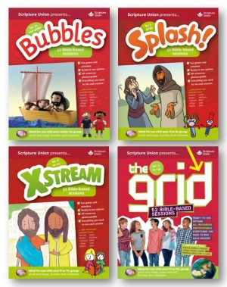
- Age and stage based unless you look at Mosaic
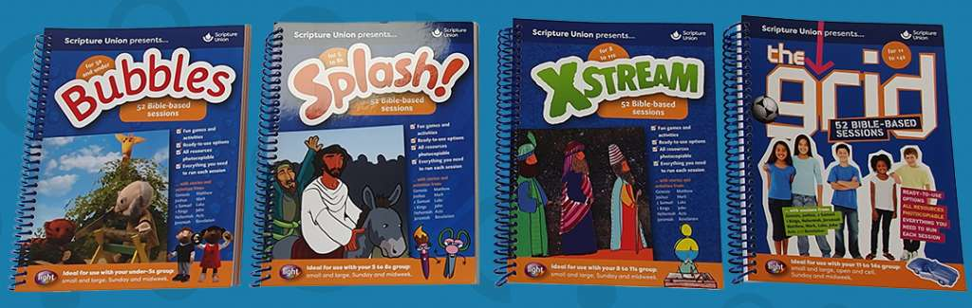
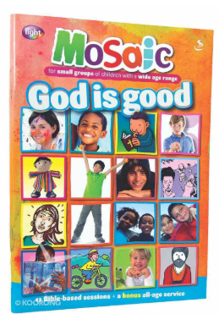

Lost Sheep
Andrew McDonough
https://www.lostsheep.com.au/

When Jesus wanted to change lives, he told stories and that’s what Lost Sheep do too. Some of their stories are about Jesus, some are by Jesus, but all of them point to Jesus. They take the spirituality of children seriously but also believe the gospel is fun. Lost Sheep create resources to assist parents, teachers and children’s workers build the faith of kids in Australia and around the world.

Country | Target Age Group | Length | Price
Australia | Adaptable for all ages. But geared to 8-12 years | Over 30 stories that can be used. | Church membership packages range from $99 to $229 depending on church size.  Individual storybooks, activity books and digital downloads are also available for varying prices.  At Home access to books: $59/month

Strengths:
- Resources such as storytelling kits, activity books, Sheep dog school (biblical background materials), iPad, eBooks and Big books.
- Lost Sheep resources are excellent for Sunday kid’s programs, all-age story telling, messy church and outreach.
- Can search stories by theme or Bible verse
- The 'Sheep dog school' biblical background materials are excellent resources for leaders
- Free samples are available for testing out these materials.
- Tailored plans available for para-church organisations
- Suitable for SRE teachers. Material accessible on interactive white boards
- At Home resources available

Considerations:
- Since Lost Sheep has no provided scope and sequence you need to pre-plan your own schedule to fit your context and desired length of time.

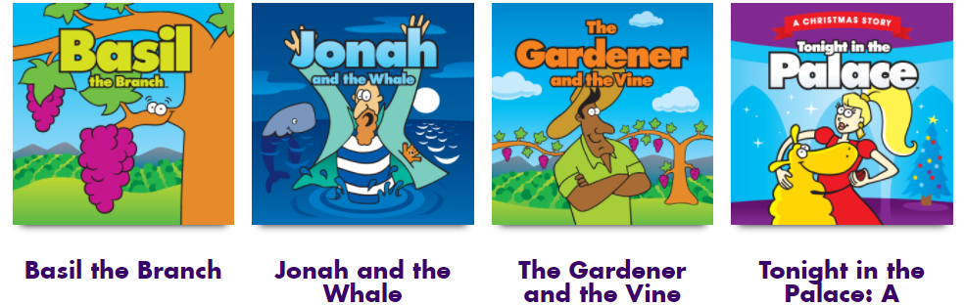

Max7

Logosdor
www.max7.org

Max7 is an online source for a variety of Bible resources, including curriculum, videos, music and training materials. It has been designed to enable the global church to work together and share resources.

Country | Target Age Group | Length | Price
Contributions from around the world. | Material can be filtered by that which is suitable for 0-3 y.o's, 3-5 y.o's,  5-8 y.o's, 8-11 y.o's,  11-14 y.o's, 14-17 y.o's | Hundreds of programs and lessons | Free.  Donations to the development of this global online resource library recommended.

Strengths:
- Free to use. Donations are used to enable children’s ministry resources to be made accessible for all parts of the world.
- Based on seven values: Bible-based, partnership, relationship, equality, leadership, creativity & transformation.
- Hundreds of program and lesson outlines are available, as well as thousands of ideas to customise lessons to suit your group.
- Easy to use website, with filters to help you find exactly what you’re looking for.
- Handy app for iOS and Android, so you can access resources on the go.
- Contributing back resources that you develop is another way to engage with the project and equip churches around the globe.
- At Home resources available

Considerations:
- Since Max7 resources come from a myriad of contributors, there is no standardised format. Lessons vary in length, format, target age group and lesson purpose.

7Ways BibleMAX Series
Logosdor
www.max7.org
Search “7Ways BibleMAX Series”

7Ways BibleMAX Series available from Max7 provides a great range of lessons in 5 week series.

Country | Target Age Group | Length | Price
Australia | 6-12 year olds.  “First Steps” is also available for 3-5 year olds. | 26 units,  with 5 lessons each.  First Steps has 7 units, with 5 lessons each. | Free. Donations to the development of this online resource library are very welcome.

Strengths:
- Free to use. Donations are used to enable children’s ministry resources to be made accessible for all parts of the world.
- Accompanied by several leaders’ guides, including “Discipling Children,” “Working with Gifted and Talented Kids,” and “Helping Children Belong.”
- Each unit contains a “Family Times” component to support the five lessons and give families the opportunity to engage with one another and the Bible.

Oasis
Logosdor
www.oasischildrensresources.com

Oasis is a Bible discovery curriculum for children that is contemporary, fun, energy packed and deliberately designed to help churches grow their children’s ministry.

Country | Target Age Group | Length | Price
Australia | 7-11 year olds | 14 series,  with 10 lessons each. | $145 per 10-lesson resource pack.

Strengths:
- Packs include a DVD with leaders’ and children’s video segments, as well as an enhanced CD with songs, manuals, and song words for projection.
- The curriculum uses a mosaic educational approach and an easy-to-follow structure.
- The program is about more than just head knowledge. Each resource pack includes a mission manual, discipling manual, and creative ministry manual. Each program has three parts, which each take three weeks. The nine weeks culminate in the Oasis celebration (Week 10) where the children minister at either a church service or on a week-day evening.

Considerations:
- The videos are now dated but content is very good

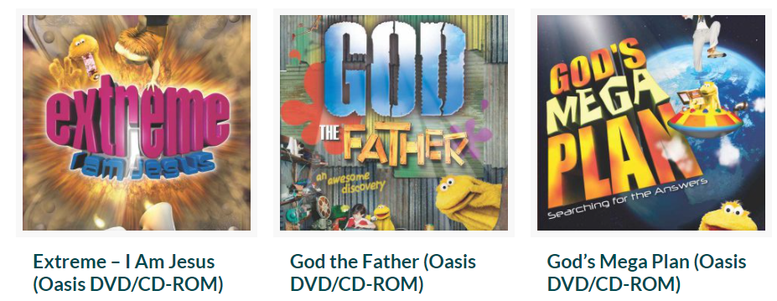

Saddleback Kids

Saddleback Church
https://store.saddlebackkids.com/

Saddleback kids aims to connect kids to God and others. Their curriculum is all about bringing the love of Christ to children and helping them understand that God loves them and wants a genuine relationship with them. The focus is on Bible-based lessons that are engaging and that generate real discussions about what God’s Message means for children today.

Country | Target Age Group | Length | Price
USA | Toddler: 2yrs and under  Early Childhood: 3-5yrs  Elementary: 6-12yrs | Toddler: 1 story each month (repeated)  Early Childhood: 5-6 week curriculum packages  Elementary: 5-6 week curriculum packages  Bible story pack: 12 stories (videos) | Toddler: coming soon.  Early Childhood: US$75 per curriculum package  Elementary: US$75 per curriculum package  Bundled packages (Early Childhood + Elementary) also available for US$100  Free

Strengths:
- Each curriculum package includes video content, teaching outlines, and resources for object lessons.
- All packages are adapted for each target age group.
- Video clips on YouTube are creative and simple
- Free Bible Story Pack available: 12 Bible stories that you can use for church: suitable for live streams, embedded on church websites or placed within your churches video content.
- At Home resource available.

Considerations:
- Since each curriculum series only lasts 5-6 weeks in general, this resource could prove expensive if you wanted to use them for extended periods such as a whole year.

Tell Me About God
Baptist Churches NSW & ACT
https://nswactbaptists.org.au/product/z-tell-god/

Twenty-six lessons which explore an attribute of God for each letter of the alphabet (God is Almighty, God is the Blessing-Giver, etc). They are primarily designed for intergenerational groups of children and adults.

Country | Target Age Group | Length | Price
Australia | Children of all ages & inter-generational groups. | 26 lessons | $20

Strengths:
- The material is suitable for both churched and unchurched families and may be a great starting place if you have people who have only recently started coming to church.
- The material is excellent in its relevance to all ages. It can be used with small children, while remaining engaging for older children, teenagers and adults.
- The material is flexible – activities can be chosen based on time available, the age levels and the group mixture.
- The curriculum values children and adults learning, growing and leading together, and the material is written in a way that enables this to take place.
- Proceeds from the sale of the book will be used to further the Simple Church Network of the NSW/ACT Baptist Gen1K vision.

Considerations:
- Only 26 sessions

The Meeting House Kids and Youth Curriculum
The Meeting House Church
http://kidsandyouth.themeetinghouse.com/

Their mission is to develop lifelong followers of Jesus. The approach of this curriculum is to teach stories within the context of the overarching Biblical narrative, so that kids and youth can learn each story and how it connects into God’s story. They also want kids and youth to see where they fit into God’s story and discover the role that God has for them as disciples of Jesus. The teaching moves from the Old Testament, to the life of Jesus, to the early Church.

Country | Target Age Group | Length | Price
Canada | Series for:  Preschool  (Infant-5yrs),  Kids (6-10yrs)  Junior High (11-13yrs)  Youth (11-18yrs) | Monthly downloadable series as well as access to past series. | Free access to download all curriculum materials once you register.

Strengths:
- Each week, the teaching is composed of four key elements:
  - God Story: a story or passage from the Bible
  - Life Story: a real-life example that brings the Big Idea to life
  - My Story: application activities
  - Our Story: resources for families to use at home.
- Highly engaging material for kids and straight-forward for leaders to use. Activities are clearly outlined and structured.
- Series for each age group aligns, so all age groups from preschool to youth can be learning from the same Bible stories at the same time, in an accessible, age-appropriate way.
- At Home resource available.

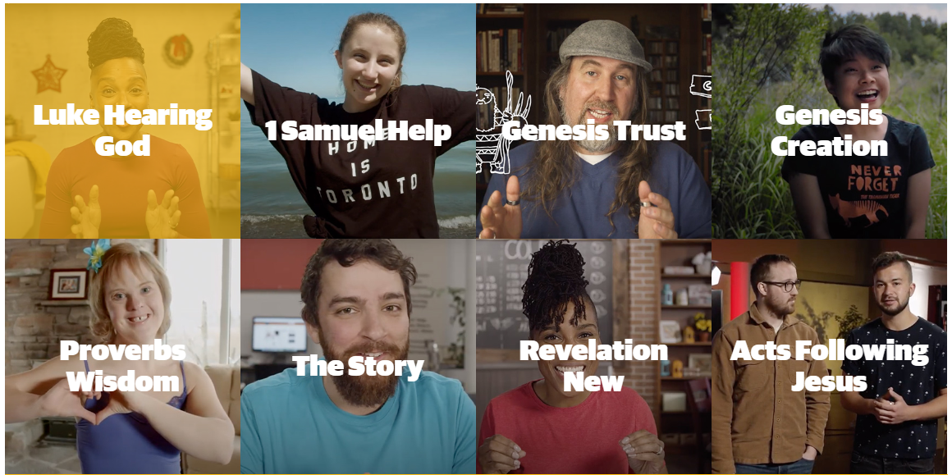
Think Orange
rethink Group
www.thinkorange.com

“Orange is built around the truth that what we teach kids should be built around how we teach kids. Every story, every principle, every truth reinforces for everyone what it means to love God and be loved by God.”

Country | Target Age Group | Length | Price
USA | Separate material for:  Preschool  (toddlers, 3-5 yrs)  Children & Preteens  Middle school  High school | Ongoing; curriculum can be downloaded monthly from the web. | Annual subscriptions:  Preschool:  US$510 (1-15 kids), US$906 (26-50 kids).  Children:  US$510 (0-25 kids), US$936 (26-50 kids).  Prices for larger groups on website. Starter, Basic and Premium tiers. Options for single age group or multi age groups.

Strengths:
- For pre-schoolers, “First Look” 3 main focus’: God made me, God loves me, and Jesus wants to be my friend forever.
- For primary “252 Basics” based on three basic truths modelled by Jesus in Luke 2:52: I need to make the wise choice, I can trust God no matter what, I should treat others the way I want to be treated.
- Suitable for small or large multi-age groups (Kindergarten – 5th Grade)

Considerations:
- Cost is significant
- Works best when the church engages with the Orange approach to ministry with children

Tru
David C Cook
http://www.truministry.com/

Tru is a spiritually forming, parent-empowering curriculum that equips children, leaders and families to know Jesus and live out a vibrant lifetime faith. Tru helps leaders, children, and their families connect to God, find their place in His big story, and respond to Him through the power of the Holy Spirit.

Country | Target Age Group | Length | Price
USA | TruBlessings: 3 year olds  TruWonder: Preschool to kindergarten  TruStory: Year 1 to Year 5  TruIdentity: Year 6-Year 8 | TruBlessings: 1-year scope and sequence  TruWonder: 3-year scope and sequence  TruStory: 3-year scope and sequence  TruIdentity: 8 and 5-week modules based on books of the Bible (53 weeks total) | Sold as quarterly curriculums, prices vary from US$49.99 to US$154.99 depending on the age group and group size.

Strengths:
- Kids see the whole Bible and how God’s Big Story connects to their own story.
- Focus on God statements shows kids that no matter the story, God is always central.
- Lessons encourage time for kids to respond to God through the power of the Holy Spirit.
- All resources are supplied with each lesson for instant access and include things like:
  - Videos
  - Storytelling Images
  - Discussion Questions (Investigate)
  - Supplemental Activities (Games: Memory, Bingo)
- Clear instructions for preparation and clear steps to follow for each lesson.
- Options for both large and small groups
- At Home Weekly – a parent resource with each week’s lesson encourages families to explore God’s Word together before children arrive at church
- At Home resource available

Considerations:
- Some churches have mentioned that significant adaptation of material has been needed
- Based on a Northern hemisphere school year. Doesn’t always fit with Australian timelines

Bible Studies for Life
LifeWay Kids
https://www.lifeway.com/en/shop/bible-studies-for-life/kids

Bible Studies for Life is a series of curriculum for all ages, babies through adults, designed to connect God’s Word to lives in an intentional way.

Country | Target Age Group | Length | Price
USA  Bible Studies for Life | Bible Studies for Life:  Preschool (1-5 yrs)  Kindergarten (5-6 yrs)  Kids (6-12 yrs) | Quarterly curriculum includes 13 sessions | $71.50 for Quick Start Kit  A variety of digital bundles available

Strengths:
- Available in various translations: CSB, ESV, NIV and NKJV.
- Families can access weekly worship experiences, prayer prompts and activity ideas.
- One Conversation overview makes it easy for parents to have spiritual discussions with their kids.
- Options for both large and small groups.
- Includes At Home package.

Considerations:
- May need to be adapted to an Australian context.

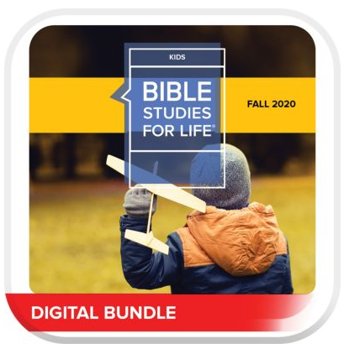

The Gospel Project
Lifeway Kids
www.lifeway.com/n/Product-Family/The-Gospel-Project

The Gospel Project for Kids immerses kids and pre-schoolers in the gospel through every story, theological concept and call to mission from Genesis to Revelation.

Country | Target Age Group | Length | Price
USA | Separate material for babies & toddlers, preschool, younger kids, older kids. | 3-year curriculum  (12 volumes,  13 lessons each) | Preschool:  US$69.99 for leader kit per term.  Children:  US$89.99 for leader kit per term.  Prices for digital packages and ‘At Home’ resources vary, based on size of kids ministry (starts at US$184)

Strengths:
- The curriculum helps children understand that the Bible is not just a collection of stories but one unified story – God’s story of redemption.
- The resources are built on a belief that the gospel message changes everything, and heart transformation can only take place when a child experiences the gospel.
- Age alignment: all ages learn same lessons
- At Home resource available.
- At Home resource includes weekly worship service, prayer prompts, activity ideas, customisable Bible study Leader guides, activity pages, colouring pages, Bible story videos, music motion videos and suggested email, social media posts and texts to send to families.

Considerations:
- There is plenty of material – so much so that some churches find it difficult to decide what to use and where to use it. There is an option (for a higher cost) to add a second hour of worship materials, which (unless you have multiple meeting times) is probably unnecessary.
- The ‘Gospel Project for Kids At Home’ resource is available after purchasing the quarterly curriculum.
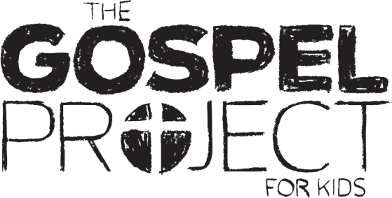

Explore the Bible
LifeWay Kids
https://www.lifeway.com/en/shop/explore-the-bible/kids

Day after day, week after week, your whole church will grow together in God’s Word one book at a time, and learn how to know, love, and invest in God’s truth. Explore the Bible: Kids engages the whole child with the truth of Scripture in its Biblical and historical context. The Bible comes to life as children unpack the transforming truth of God in a manner that is practical, age appropriate and sustainable for a lifetime.

Country | Target Age Group | Length | Price
USA | All ages (Babies, infants, toddlers, primary, teens, adults)  Younger and older children (infants – Upper Primary) | Quarterly  Quarterly | Tool Kit $72.50  Explorer Guide Magazine (US$4.55) and Family Cards ($2.95) can also be purchased separately.

Strengths:
- Offers daily application, perfect for both individual and group settings
- Can purchase Family Cards – equipping parents with discussion questions that relate to each session. Each card includes the Bible story reference and object of the week to help families continue exploring the Bible at home.
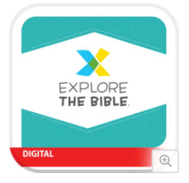
- Promotes connection between church and parents – helps parents apply biblical concepts throughout the week at home
- Includes At Home package.

Considerations:
- Some of the content may need to be adjusted to suit the Australian calendar.

Lectionary based resources

Seasons FUSION
Seasons of the Spirit
www.seasonsonline.ca

This resource is designed to support congregational life as we worship, live, learn, and grow as disciples, and as communities of faith. It is designed for time together as well as apart that is holistic, for all ages. SeasonFUSION serves as a starting point for your congregation to plan and adapt what will work best for you.

Country | Target Age Group | Length | Price
Australia, US & UK | Multi-age (3 yrs +) | Quarterly curriculum  Yearly curriculum | Online access: $118  Printed copy: $139  Online access: $290.71  On disk: $298.35 (yrly option available only)  Printed copy: $323

Includes: weekly calendar page (lists liturgical observances for the week), Biblical background (commentary), reflective questions, Focus for worship, learning and serving, Worship outline (3 pages of worship resources designed for all ages), poetry and prose, Bible story (for church or home), stations (to set up at church or mid-week groups), Children’s activity leaflets, communion prayers, at Home resource for families, MP3 audio stories containing recordings of Bible stories and more.

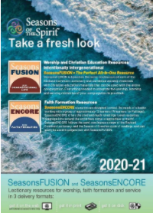
Strengths:
- Designed for all ages
- Easily adaptable for any location – home, church, outdoor space
- Great for churches with few children or young people.
- Can be used At Home

Considerations:
- This resource is based on the lectionary.

Spill the Beans
http://spillbeans.org.uk/

Spill the Beans is a lectionary-based quarterly worship and learning magazine resource for children of all ages.

Country | Target Age Group | Length | Price
Scotland | Infants, toddlers, primary, teens) | Quarterly magazine | 12 pounds (approximately $22)

Strengths:
- Intergenerational resource – suits children of all ages
- Audio-visual resources are regularly added to a Facebook page: http://spillbeans.org.uk/ (including PowerPoints, songs for online worship and stories).
- Offers resources for families to worship at home
- Affordable
- Can be used At Home

Considerations:
- The resource is only available each quarter, thus there may not be enough activities/crafts for the three months’ worth of Sunday School lessons.
- This digital resource may take some time to download. It is approximately 15 MB. The file can only be downloaded using a link three times; file needs to be saved to your computer as soon as you have downloaded it.
- This resource is based on the lectionary
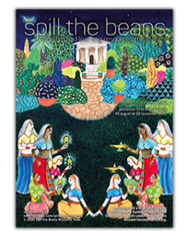

ROOTS
ROOTS for Churches
https://www.rootsontheweb.com/about-roots/children-young-people-resources

ROOTS Children & Young People resources is a magazine, based on the lectionary, designed for children of all ages to encounter and explore the Bible and discover how it relates to their everyday lives. It is used in conjunction with the Adult & All Age resource so that children can learn from the same Bible passage as the adults.

Country | Target Age Group | Length | Price
USA | 3 – 16 yrs | 2 months (1 issue)  Yearly | Subscription based. 10.85 pounds per issue ($19.97). Covers 2 months of Sundays.  Yearly option also available: 6 issues for 49.50 pounds ($91.10).

Strengths:
- Can be adapted to suit the needs of your church. E.g. short/long session, location (church, school, unique space), frequency of meeting (weekly, fortnightly, monthly), age range (a range of ages all together or age banded groups).
- Provides song suggestions to accompany the passage of scripture. The songs are categorised by age (for under 5’s, under 12’s and 12+).
- Set time frames provided for each activity/session.
- Each session offers ‘Do, Make, Pray and Sing’ activities.
- Magazine offers 2 months’ worth of Sunday materials for children and young people – including access to online support materials for activities and sessions
- Can be used At Home

Considerations:
- The song suggestions are not on CD. However, there are direct links to YouTube for the songs listed.
- Leaders will need to prepare well in order to select what is appropriate for their audience.
- This resource is based on the lectionary.

